LIVE ON TEAMS THIS HARVEST AND HALLOWEEN!

 | Wednesday 20th October | Thursday 21st October | Friday 22nd October
11 am | You will receive activities via email and can access these on the school website class pages.  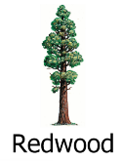  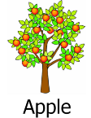  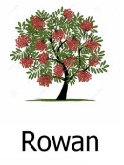  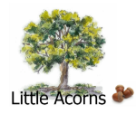  Individual TEAMs calls will be arranged by class teams. These will be discussions around IEP targets and how you can support your child to learn at home. | Halloween Sensory Story with Tracey and the Apple class Team  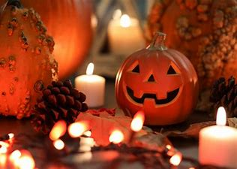 | 11 am  Halloween and Harvest Music with Rhiannon and the Oak class team  
2 pm |  | Bucket Time with Nicky and Rachel and the Oak and Rowan class teams   | 2pm  Learning to Learn ‘Sparkle and Shine’ Assembly with Helen and the Redwood team  *Guest appearance Rhiannon and lots of sparkly stuff  
Welcome to Oak, Rowan, Apple and Redwood Sensory Festival. Please join us for all things Harvest and Halloween. You are welcome to join all of the sessions or just the ones that fit with your timetables at home.

